**Muhammad Ali Jinnah University**

**Karachi, Pakistan**



**DISCRETE PROGRAMING PROJECT**

**Name: Syed Mustafa Hassan**

**Student ID: FA21-BSCS-0030**

**Section: AM**

**Batch: FA21**

**Problem 1**

SOURCE CODE:

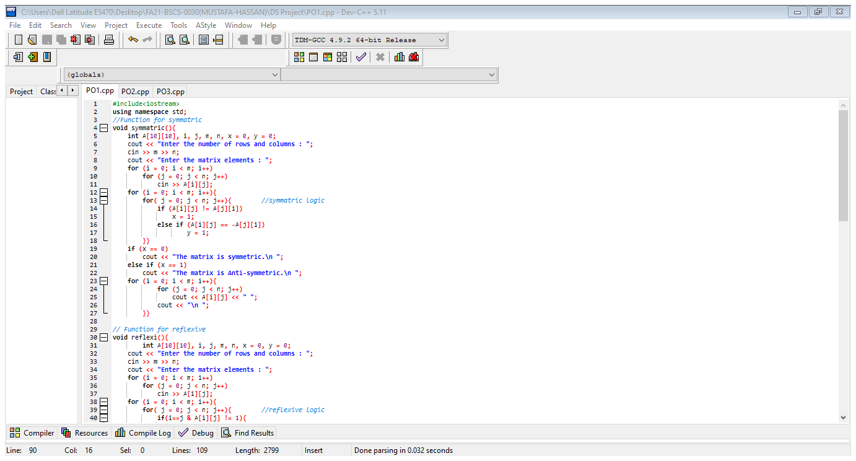

OUTPUT:

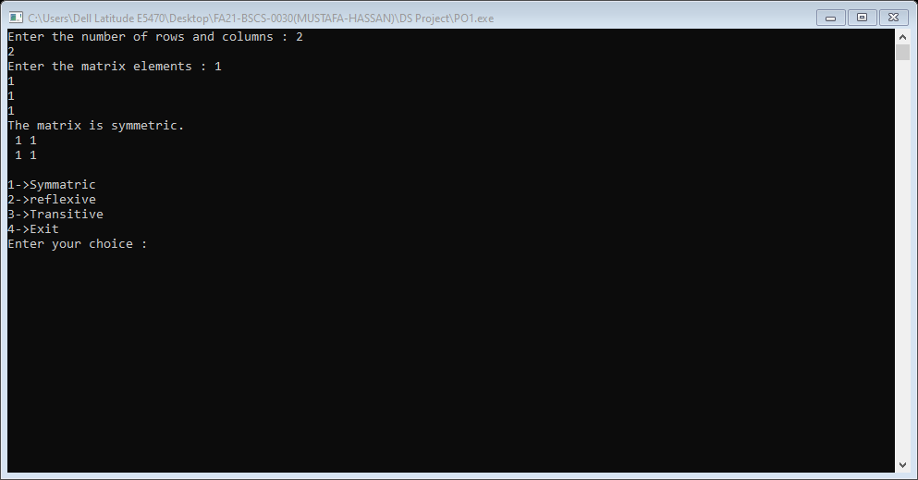

**Problem 2**

SOURCE CODE:

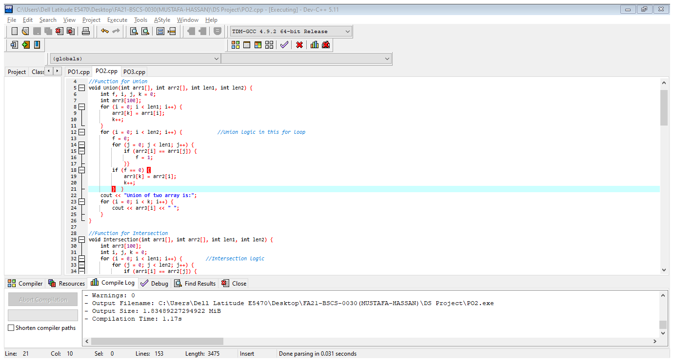

OUTPUT:

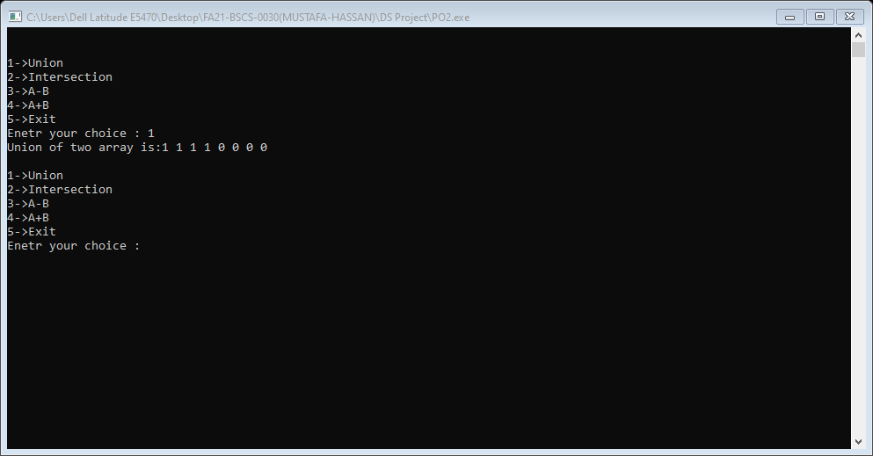

**Problem 3**

SOURCE CODE:

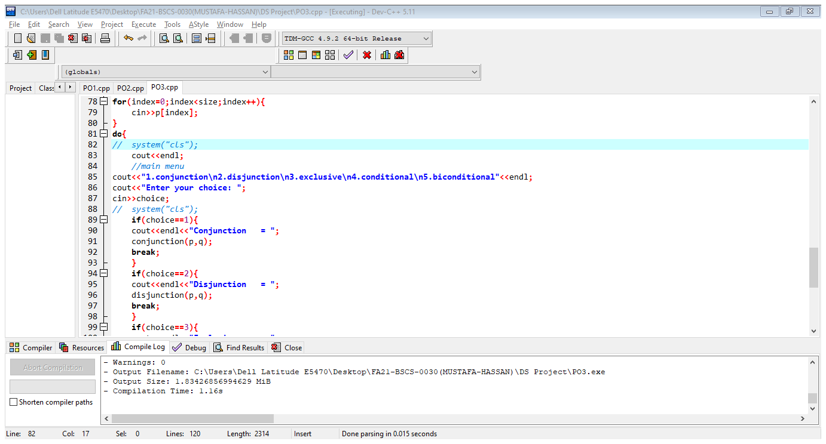

OUTPUT:

